http://www.metronews.ca/news/vancouver/2017/01/25/overdose-response-app-winners-of-health-hackathon.html

[News](http://www.metronews.ca/news.html) / [Vancouver](http://www.metronews.ca/news/vancouver.html)

**Overdose-response app included in winners of Health Hackathon**

**When computer-science student Sean Bergunder heard how bad the overdose crisis had become from his mom, a nurse, he decided to do something about it**

* Share on Facebook
* [Reddit this!](https://www.reddit.com/submit)

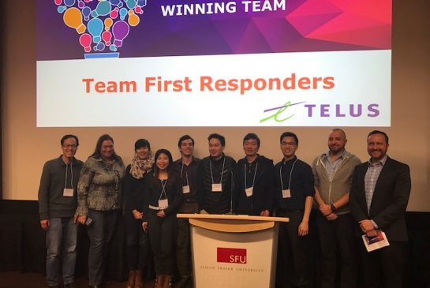

Courtesy Fraser Health

The First Responders were one of the winning teams at this weekend's Health Hackathon.

**By:** [Wanyee Li](http://www.metronews.ca/authors.wanyee-li.html) Metro Published on

One of the winning ideas from last weekend’s 48-hour health hackathon, hosted by Fraser Health, is an app that would crowdsource overdose reports in real time to better connect people carrying naloxone with people who are overdosing.

An SFU computer science student and his team, The First Responders, came up with the timely – and potentially life-saving – idea. Data is Sean Bergunder’s passion, he told Metro.

“I am more attracted to healthcare data sets. That might be because my mom is actually a nurse so I hear about these things a lot.”

* [**Fraser Health hosts B.C. health hackathon**](http://www.metronews.ca/news/vancouver/2016/12/12/fraser-health-hosts-bcs-first-ever-health-hackathon-.html)

That inspired him to create a software program that would gather healthcare data relating to overdoses in one place to help healthcare professionals reach those most in need. But that data was not available for privacy reasons.

That roadblock gave him the idea to crowdsource that data instead.

The idea is simple: When an app user reports a nearby overdose, a flag will appear on a map and nearby healthcare workers, or people carrying naloxone, will be notified.

“When someone presses the button to report an overdose, it would broadcast their location to other users of the app and we would log that information then we would have it available to us,” he said.

The app could shorten response times people currently face when overdosing, said Dr. Victoria Lee, Fraser Health’s chief medical health officer.

“It’s expanding the number of people who would be able to address and deal with overdoses that we see in public places or privates residences.”

But the hard work of implementing the idea and creating a real-life product remains.

Bergunder and several other health hackathon teams are in the running for eight spots in a 20-week software incubator program, hosted by Innovation Boulevard. Fraser Health will choose the people for that program in the coming weeks, according to Lee